Top Up Online By Student

Document Information

|  |  |
| --- | --- |
| **Document Title** | Title of use case – Verb Noun phrasing is almost always the most appropriate! |
| **Document Owner** |  |
| **Version** |  |
| **Status** |  |
| **Date** |  |

1. Brief Description

This use case allows a student to add funds to the their account balance using online wallets or bank cards.

1. Actors

* Student

1. Trigger

The student decides to top up their account balance.

1. Pre-Conditions

* The student must be logged into the system.

1. Post-Conditions

* The student's account balance is increased by the amount of the top-up.

1. Basic Flow
2. The student logs in to the system.
3. The student navigates to “Account Balance” section.
4. The system displays the current account balance.
5. The student selects “Top up” button.
6. The student selects the payment method.
7. The student enters the top-up amount.
8. The student selects “Add” button to confirms the top-up.
9. The system call the selected payment gateway.
10. The payment gateway displays the necessary payment information.
11. The student enters the required payment information.
12. The student confirms the payment.
13. The payment gateway process the payment.
14. The payment gateway updates the processing result to the SLOS system.
15. The system updates account balance to reflect the top-up amount.
16. The system returns the student to “Account Balance” page.
17. Alternate Flows
18. Exception Flows

* 7a. If the student enters invalid top-up amount (>5.000.000), the system displays an error message and the student must enter a lower amount at step 4.
* 8a. If the system does not call the payment gateway successfully, the system displays an error message and returns to step 4.
* 9a. If the student does not want to continue the payment process, they can select “Cancel” button or any similar button depends on the payment method to cancel the payment process. The system returns the student to step 4.
* 11a. If the required payment information is not correct, the payment processing displays an error message and the student must enter the correct information or cancel the payment process.
* 14a. If the payment processing is not successful, the systems displays an error message and returns to step 4.

1. Business Rules

* The maximum for each time to top up is 5.000.000.
* Only online wallets and bank cards available for selected are accepted as payment methods for online top-up.
* The online top-up amount should be positive.

1. Non-Functional Requirements

* The system should be available 24/7 with 99% uptime.
* The system should process the payment processing and balance calculating quickly (5s).
* The system should provide clear and concise messaging to the student throughout the top-up process.

1. Supplemental Requirements
2. Visual Model

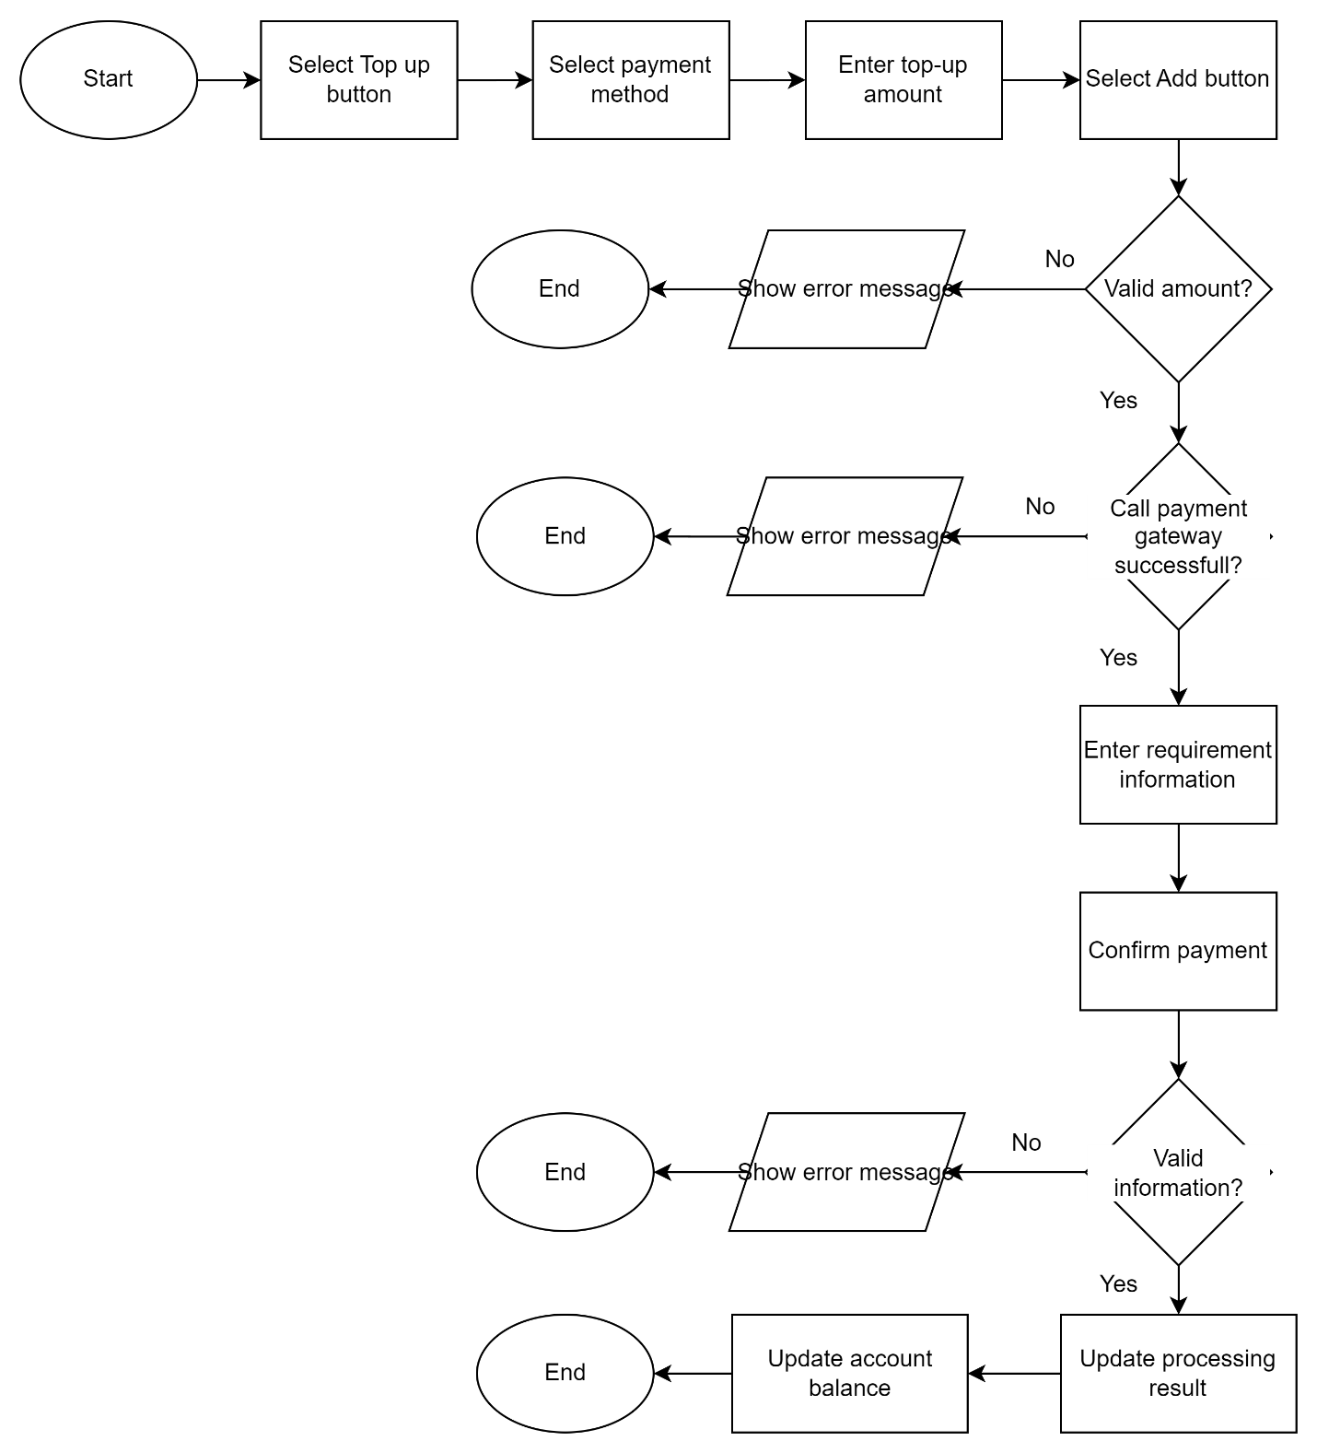

Revision History

|  |  |  |  |  |
| --- | --- | --- | --- | --- |
| V. | Date | Author | Description | Status |
|  |  |  |  |  |
|  |  |  |  |  |